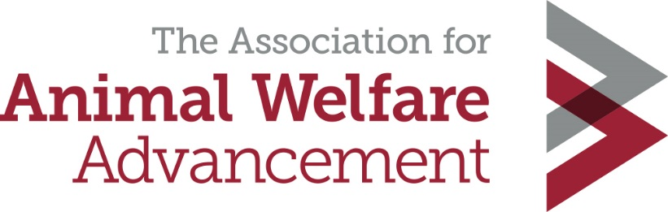
Adoption Disclosures Model Practices
Disclosure Defined
An adoption disclosure is a document that is presented to an adopter when an animal has a known or suspected medical or behavioral condition that may continue to need treatment or management in the future.

This waiver is an area where precision in language is vitally important and disclosures should be written in consultation with an attorney. Liability laws vary by state, so it is wise to retain an attorney, even if an organization must pay extra to attain sound legal advice.

A disclosure must be presented to adopters when an adopting organization knows or suspects an animal being adopted:
- Has a medical condition that will require continued treatment
- Had a medical condition that has been successfully treated but is likely to have an impact on the animal’s health in the future
- Has a history of behaviors that may cause challenges in the home
- Has displayed behaviors while in the custody of the organization that may cause challenges in the home
- Has undergone behavioral rehabilitation that will require continued rehabilitation and/or management after adoption
Disclosures do not have to be presented if an animal’s medical or behavioral condition has successfully been treated and no future consequences from that condition are suspected. The diagnosis and treatment must be disclosed in the animal’s complete record.
Elements of a waiver
- Animal’s name
- Species
- Age
Gender
- Clear statement of the identified medical or behavioral condition
- Organization’s name and adopter’s name

Example:
[Organization] hereby discloses to [adopter name] that this animal has exhibited the following behavior while in our care and/or prior to coming into our care.

I recognized that this animal may need further behavioral management immediately or in the future and will be responsible for all charges incurred. I recognized that this behavior condition exists and I am willing to adopt the animal at this time. I accept that upon signature of this agreement the [Organization] will not subsidize or make payment toward the care of this animal.

The disclosure must clearly state:
- The name and nature of the condition
- A plain language explanation of the condition
- Whether additional treatment or management is needed
- What additional treatment or management is needed
- Whether this condition may be chronic or is expected to resolve with treatment (prognosis)
- If the condition may put the safety of people or other animals at risk
- Whether the condition is contagious to other animals or people
- Any post adoption resources that will be made available; clearly state if there will be no future care provided by the organization

If ongoing treatment is required the disclosure must outline the treatment needed. The disclosure may refer to the animal’s medical or behavioral record and should clearly outline future treatment recommendations.

The disclosure must be accompanied by a complete medical or behavioral treatment record or both, that is written in language that will be understood by the adopter’s veterinarian or behaviorist/trainer (See The Association Adoption Best Practices “records” section).

Appropriate personnel who have an understanding of the condition must review the disclosure with the adopter to ensure the adopter understands the current condition and future needs of the animal.

Signatures

Space must be provided for an authorized representation of the adopting agency and the adopter to sign the agreement.

EXAMPLES:

I, the Adopter, have read this disclosure, understand the pre-existing condition this animal has and understand that future treatment or management is needed. I understand that I am solely responsible for any future treatment.
Adopter Signature ________________________________ Date __________________________
Staff Signature ___________________________________ Date __________________________

